**ADDING A HOST TO MONITOR**

In this tutorial, I will add an Ubuntu host to monitor to the Nagios server .

Take one AWS instance or local terminal

Now i am doing in my local machine(ubuntu terminal)

Here i have only one ip is there ,so i can added that ip address and host

Check the ip address in local machine

$ifconfig

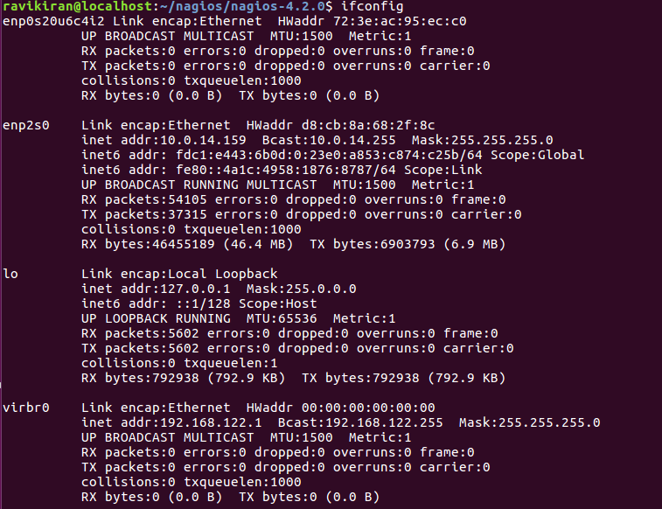

Now install the NRPE service

$sudo apt-get install nagios-nrpe-server nagios-plugins

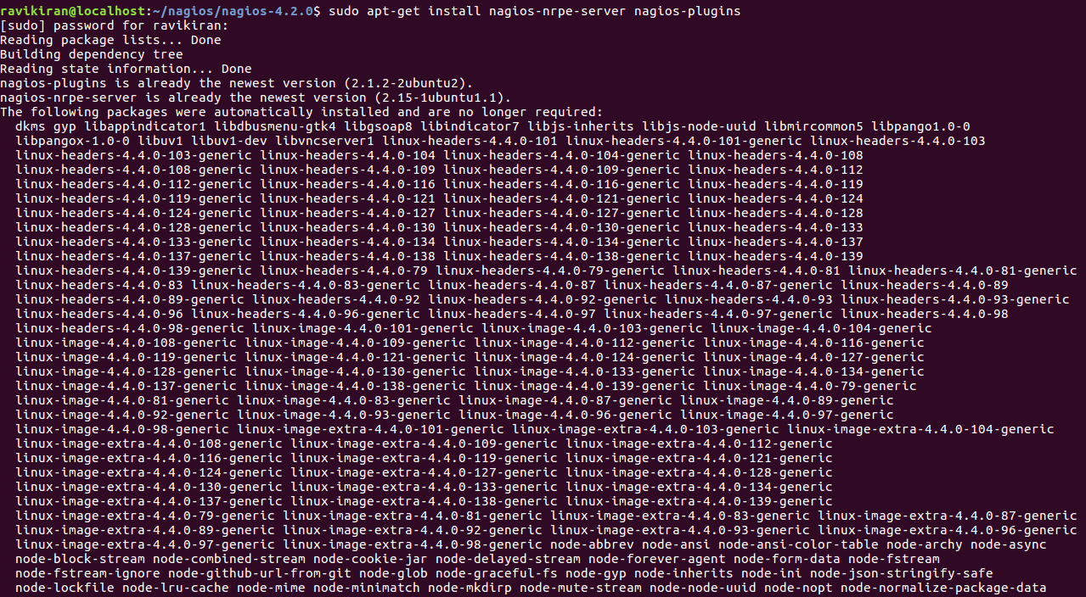

Now configure the NRPE

After the installation is complete, edit the nrpe file /etc/nagios/nrpe.cfg

$nano /etc/nagios/nrpe.cfg

and add Nagios Server IP 192.168.1.9 to the server_address.

*server_address=192.168.1.9*

*Save it*

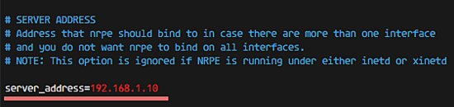

Restart NRPE

$service nagios-nrpe-server restart



Then create a new file for the host configuration in /usr/local/nagios/etc/servers/.

$nano /usr/local/nagios/etc/servers/ubuntu_host.cfg

Added the content and save

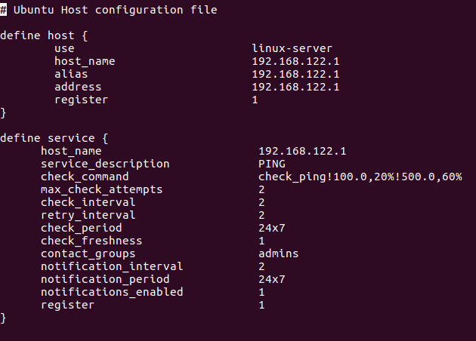

You can find many check_command in /usr/local/nagios/etc/objects/commands.cfg file. See there if you want to add more services like DHCP, POP etc

And now check the configuration in case any error we will find that errors by using this command

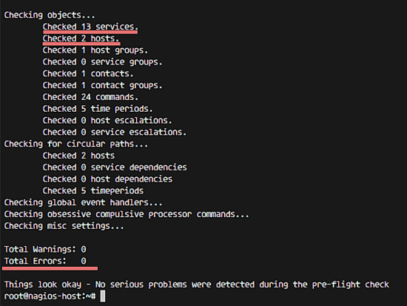

### **Restart all services**

On the Ubuntu Host start NRPE Service:

$sudo service nagios-nrpe-server restart



... and on the Nagios server, start Apache and Nagios:

$service apache2 restart



$sudo service nagios restart



### **Testing the Ubuntu Host**

Open the Nagios server from the browser and see the ubuntu_host being monitored.

The Ubuntu host is available on monitored host.

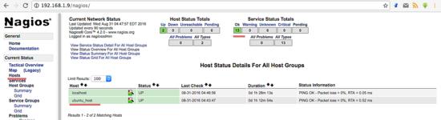

All services monitored without error

